Expos 20 244, Fall 2018  Meetings: Tues/Th, 12-1:15pm  Location: Barker 218 | Preceptor: Ezer Vierba  vierba@fas.harvard.edu  Office: 1 Bow St., 223  Office hours: T/Th, 2-2:45pm
Buddhism, Mindfulness,
and the Practical Mind
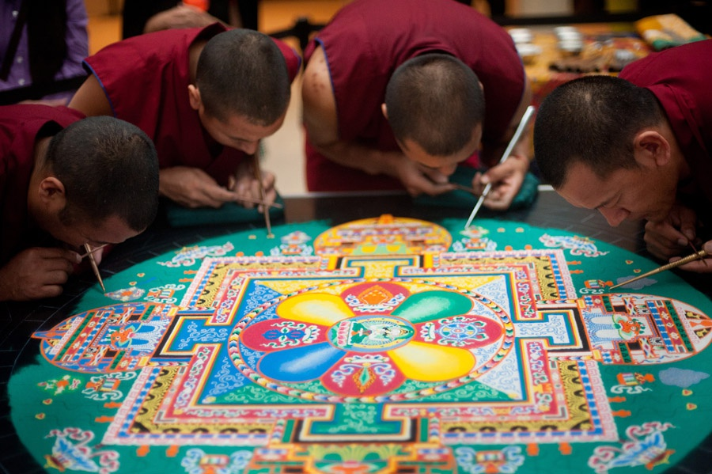
Today, mindfulness is touted as a panacea, the secret to happiness and health, superb sex and unparalleled productivity. The hype is not entirely new, however. For decades, ostensibly Buddhist ideas have been tossed around in the West as recipes for success in just about any art or craft. But what hides behind this craze? Can Buddhist teachings offer us tools with which to achieve our goals, or are we corrupting Buddhism by using it in such a way? What have artists and practitioners thought of the use of meditative tools, and how have they integrated Buddhist terms like “bare awareness” and “emptiness” into their work?
In order to answer such questions, we will start the course with a reading of the Satipatṭhāna Sutta, the Buddha’s instructions on mindfulness meditation. A close reading of the text in our first unit will give us a glimpse of the ancient Buddhist practice, its complexity and richness. As we move into our second unit, we will read the text that first gave the West the idea that Buddhism can allow us to “hit the mark” without trying to do so, Eugen Herrigel’s bestselling 1948 book, Zen in the Art of Archery. Using Edward Said’s classic work, Orientalism, we will ask if Herrigel was romanticizing Zen Buddhism, and if he was, what the consequences of such a romanticization have for Japan and the West. In our last unit, we will dive into the contemporary debate about "McMindfulness" by looking at what scientists, artists and Buddhist practitioners have said about the compatibility of Buddhism with its modern, secular appropriations.
As we read these texts, we will also practice mindfulness meditation, as well as various other forms of Buddhist meditation. In doing so, we will think about these meditations both practically and critically, at the same time as we refine our analytical understanding of Buddhist ideas.

Required Readings
- Eugen Herrigel, Zen in the Art of Archery (1948).
- Joseph Goldstein, Mindfulness: A Practical Guide to Awakening (Sounds True, 2013).
Selections of the following books which are required readings will be available online. However, you may choose to buy any of them as well.
- Analyo, Satipatthana: The Direct Path to Realization (Windhorse Publication, 2003).
- Edward Said, Orientalism (1979).
- Natalie Goldberg, Writing Down the Bones (Boston: Shambhala, 1986).

Assignments
- You will submit various short (one-page) response papers. These papers are designed to help you prepare for class, and you should plan to spend only a short amount of time on them.
- You will submit a draft of each of the three larger essays. On each draft, you’ll receive detailed comments from me (in writing and in 1-1 conferences).
- You will include a cover letter with each essay or draft you submit. In this short letter, state your research question and your thesis; mention what you are still trying to figure out; what aspect of your research is not yet completed; and what parts of the essay you think you need help with.
- We will have an in-class draft workshop after you submit each draft. For this workshop, I will choose two or three students’ drafts, and we will look at them closely. In preparation for the workshops, you will submit written comments on the students’ work. The comments you will provide will help you become better editors of your own work.
- We will meet for a 20-30 minute conference after each draft you submit, and talk about strategies for revising your essay.
- The key to good writing is revision. You will therefore revise each of your drafts before submitting a final version of the essay for a grade.
- In this course, you will submit three academic essays:
* Essay 1 is a four-page close reading of any part you choose of the Satipatthana Sutta. While you should probably consult Analayo’s work and/or Joseph Goldstein's book, you must develop your own argument about the sutta, and use evidence from the text to make your case.
* In Essay 2, you will use the analytical framework that Edward Said developed in Orientalism to explore Eugene Herrigel’s essay on Japanese archery. In this 5-8 page essay, you will engage in the scholarly debate about Herrigel’s work, using your understanding of Orientalism, as well as evidence from Zen and the Art of Archery, to make your argument.
* In Essay 3, you will examine any subject related to the application of Buddhist practices in the modern world. In this 8-12 page essay, you will develop your own research question and argument, using primary and secondary sources of your choice.
Descriptions of all three assignments will be found on our Canvas site (under Assignments), and we will discuss each of them in class.

Other Course Policies
- Grading: I will grade only the last version of your essays, not the drafts. The overall course grade will be determined as follows:

Attendance and Participation: 12%
Paper 1: 20%
Paper 2: 30%
Paper 3: 38%

- Attendance and participation: The policy of the Harvard College Writing Program is as follows. If you miss more than one class without the excuse of a religious holiday or illness, you will receive a formal warning letter, copied to your Freshman Dean. If you then miss another class without a legitimate reason, you are eligible to be officially excluded from the course. Please note that absences to participate in athletic or other extracurricular activities are not excusable. If you have to be absent for a religious holiday or other important event, please speak to me before the date you will be away. Participation is the key to our class’ success. I expect you to come to class having done the readings, and having submitted the response papers.
- Deadlines: Our class will move very quickly, so you must submit work on time. I will only accept late work if the student contacts me to request an extension well in advance of the deadline, and has a compelling reason. Otherwise late work will receive a significant grade penalty.
- Completion of Work: The policy of the Harvard College Writing Program is as follows: You must complete all three of the required courses essays (including drafts) in order to pass the course. All work must be completed by the relevant deadline unless you have made prior arrangements with me for an extension. If you then miss the extended deadline, you may be excluded from the course.
- Collaboration Among Students: Developing or refining ideas in conversation with other students, and through peer review of written work (including feedback from Writing Center tutors) is recommended. If you would like to acknowledge the impact someone had on your essay, it is customary to do this in a footnote at the beginning of the paper. As stated in the Student Handbook, “You do not need to acknowledge discussion with others of general approaches to the assignment or assistance with proofreading.” However, all work submitted for this course must be your own: in other words, writing response papers, drafts, or revisions with other students is expressly forbidden.
- Academic Honesty: All work submitted for this course must be your own work. Any outside sources you use must be cited properly. Any student submitting plagiarized work is eligible to fail the course and will be referred to the college’s Administrative Board for further disciplinary action, including expulsion from the university. If you have questions about what constitutes plagiarism, consult the relevant sections of Harvard Guide to Using Sources and/or speak with the instructor.
- We will be using the Chicago Manual of Style Notes and Bibliography system of citation. For your convenience, you may access the manual either online (in this link) or at Harvard libraries.

Unit 1 – The Buddha’s Direct Path to Realization

Tuesday, Sep 11
Vanessa Loder, “The Most Surprising Way To Increase Employee Wellbeing And Productivity (That Costs Almost Nothing).” Forbes, March 25, 2015.
Satipatthana Sutta (The Discourse on the Establishing of Mindfulness) Majjhima Nikaya 10. Look quickly over the entire text, but then read the first three parts (through the end of 1.3 “situational awareness”) a bit more carefully.

Thursday, Sep 13
Read handout: The 'Art' of Close Reading
Read Peter Harvey, "The Buddha and his Indian Context" (available on Canvas).
* Fill in a student introduction form. Upload the form on Canvas (Assignments >> Student Introductions).
** Having uploaded your introduction form, come meet me for a 5-10 min chat.

Response paper 1: "Find a problem in the text" due Monday, Sep 17, at 7pm. Upload your paper to Canvas (assignments >> Response paper 1.)

Tuesday, Sep 18
Read: Satipatthana Sutta 1.4 through the end of 4.1 (The Hindrances)
Try to think of ways in which to formulate a research question based on the problem you found in the Satipatthana Sutta. Consider what kind of thesis you could pose as an answer to that question; and what evidence from the sutta you could invoke to support your thesis.
*** Optional Reading: Analyo, Satipatthana: The Direct Path to Realization (Windhorse Publication, 2003). Harvard Coop and as a free pdf. (If you're interested in comparing translations, see either Analyo’s translation, or https://www.wisdompubs.org/landing/satipatthana-sutta ***

Thurs, Sep 20
Come to class with an outline of your draft. It’s okay if it’s a very, very rough outline.

*** Draft of Essay 1 Due Friday, Sep 21, 7pm. (Upload it to Assignments >> Essay 1 Draft. )***
*** 1-1 conferences with me will be held between Monday and Friday. Please sign up for a slot on the Canvas scheduler. ***

Tues, Sep 25
Read: "Elements of an Academic Argument" handout.
Read Satipatthana Sutta 4.5 (The Truths) through the end of the sutta.
Read the Kālāma Sutta

Thurs, Sep 27
Essay 1 Workshop:
Read and comment on students’ drafts (Modules >> Unit 1 Readings). Download and read the “Workshop Nuts and Bolts” handout. The last page of the handout is a form that will help you organize your comments on the students’ essays you’re commenting on. Bring two hard copies of your comments on each student’s draft to class, as well as a printed copy of the students’ essays (with your marginal comments and line-edits).

* Response Paper 2: “Describe a clinging.” Due Monday, Oct 1, at 7pm. Upload your paper to Canvas (assignments >> Response paper 2.)

Tues. Oct 2
Read Gaipa's "Conversational Moves" handout.

Thurs. Oct 4
Revision Bootcamp. Bring laptop and material you need for revising your essay.
Look at Owl's sample Chicago Style paper, as well as at the instructions on how to submit a revised paper. Ensure that your own paper is edited accordingly.

*** Revised Essay 1 Due Friday, Oct 5, 7pm. (Upload it to Assignments >> Essay 1 Revised. )***

Unit 2 – Zen, Archery, Orientalism

Tues, Oct 9
Eugen Herrigel, Zen in the Art of Archery (1948). Read first part.

Thurs, Oct 11
Herrigel, second part.

* Response Paper 3: Keyword – Orientalism. Due Monday, Oct 15, 7pm.

Tues, Oct 16
Edward Said, Orientalism, Introduction and ch. 1.i

Thurs, Oct 18
Said, Orientalism, rest of ch. 1, as well as Ch.2 iv.

* After reading the "They Say, I Say" handout, please write Response Paper 4: "They Say, I Say” Due Monday, Oct 22, 7pm.

Tues, Oct 23
Shōji, Yamada. "The Myth of Zen in the Art of Archery." Japanese Journal of Religious Studies 28, no. 1/2 (2001): 1-30. (On canvas)
Steven Heine, Zen Skin, Zen Marrow: Will the Real Zen Buddhism Please Stand Up? (Oxford U Press, 2008). Ch. 1. (On canvas)

Thurs, Oct 25
Library Visit

*** A draft of Essay 2 is due Friday, Oct 26, at 7pm. (To upload: Assignments >> Essay 2 Draft). Please sign up for a draft conference with me for the following week.***

Tues, Oct 30
Ron Purser and David Loy, "Beyond McMindfulness," Huffington Post, July 1, 2013.
James Herron, Counter-Arguments handout (Canvas => Resources)

Thurs, Nov 1
Essay 2 workshop:
Read and comment on students’ drafts. Download the “Workshop Nuts and Bolts” document (Modules >> Resources and Handouts); fill out the last page of this document and print it. Bring two hard copies of your comments on each student’s draft to class.

Unit 3: Buddhism Applied, Appropriated or Incorporated?

*** Response Paper 5, a short proposal for what you plan to do in Essay 3, will be due Monday, Nov 5 on 7pm.

Tues, Nov 6
Monteiro, Musten and Compson, "Traditional and Contemporary Mindfulness: Finding the Middle Path in the Tangle of Concerns." Mindfulness (2015) 6:1–13.
Purser, "Clearing the Muddled Path of Traditional and Contemporary Mindfulness: a Response to Monteiro, Musten, and Compson." Mindfulness (2015) 6:23–45

Thurs, Nov 8
Watch: Richard Davidson, “Well-Being is a Skill,” talk given at Wisdom 2.0, 2015.

***Your revised Essay 2 is due on Friday, Nov 9, at 7pm ***
* Response Paper 6: Proposal for final essay and annotated bibliography due Tuesday, Nov 13, 7pm.*

Tuesday, Nov 13
Watch: Tania Singer, "Plasticity of Empathy and Prosocial Motivation: From Outgroup Hate to Ingroup Favouritism," Talk given at IEA Paris, 2015.

Thurs, Nov 15
Kurzban, Robert, and C. Athena Aktipis. "Modularity and the Social Mind: Are Psychologists Too Self-ish?" Personality and Social Psychology Review 11, no. 2 (2007): 131-49. (Canvas)
UNC Writing Center, Conclusions (handout available on Canvas)

Tues., Nov 20
Watch: Taking the Essence: Sand Mandala of the Buddha of Compassion
Read: Chögyam Trungpa, Dharma Art (selections)

*** Thanksgiving Recess (Nov 21-25) ***

Tues, Nov 27
Natalie Goldberg, Writing Down the Bones (selections)

Thurs., Nov 29
Watch: Walk with Me. Marc J. Francis and Max Pugh, dirs. (USA, 2017).

*** A draft of Essay 3 is due Thursday, Nov 27, at 7pm. ***

Tues, Dec 4
Last class!
Please bring a laptop to this class.

*** Instead of 1-1 conferences, we will hold small workshops with 3 students each, between Tuesday, Dec 4, and Thursday, Dec 6. Please sign up for these workshops early. Come prepared to the workshop with hard copies of your friends’ drafts, as well as a printed version of your comments on the Workshop Nuts and Bolts form. ***

*** Revised final essay due Thursday, Dec 13 ***

