Expos 20, Harvard University
Laugh Riots: The Uses and Abuses of Political Humor
Fall, 2018

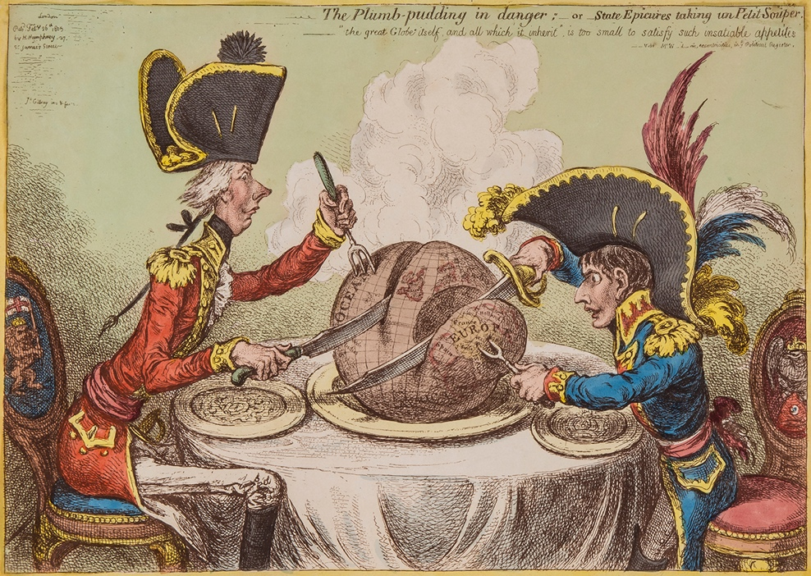

Monday and Wednesday, 12pm and 1:30pm Dr. Kip Richardson
Memorial Hall 303 krichard@fas.harvard.edu
Office hours: Wednesday, 9:30-11am, Thursday 12-2pm 1 Bow St., 2nd Floor, #231

Course Overview

By some accounts, we are living in a golden age of political satire. To established veterans of political comedy like Saturday Night Live and the Daily Show have been added a crowded retinue of late night and internet satirists, each with their own humorous book, parody Twitter account, or comedy special. Clips of comedy shows or widely-shared memes have themselves become newsworthy items, often generating a familiar cycle of reproach, outrage, defense, and apology. Yet many other critics have declared satire dead, or perhaps merely impotent, a victim of the surreality and self-parody of the modern moment. The popular hashtag, #nottheonion, gets at this interpretive dilemma: how can you mock the daily news when it already seems laughably outrageous?

In this course, students will have the chance to consider the fate and viability of social and political satire in the modern world. What is its value to contemporary democratic discourse? Whose interests does it serve? What kind of work does it perform for us? Using a number of high-profile case studies of satirical controversy, we will have a chance to consider these questions in detail.

In addition, this is a course in expository writing dedicated to teaching you how to write effectively in the different courses that you will encounter while at Harvard. The course places a special emphasis on argument and analysis—elements that will allow you to cultivate greater power and persuasiveness in your writing. In general, the course is intended to help you develop originality in your prose, but always in ways that are explicitly supported through evidence. Our material also will help you to work with different forms of data and evidence so that you will be better able to apply your writing skills across diverse disciplines and assignments. Expos 20 will steer you away from common problems in academic writing, such as evasiveness, formula, and unnecessary abstraction. Instead, we will explore the ways in which our writing can become more direct, specific, and engaging.

Essay Topics

Unit 1 Essay: Intervene in a Debate

In Unit 1, students will be asked to consider the ethical responsibilities of satire. Are there moral lines that satirical works should not cross? Or should they be largely exempt from everyday moral norms? In other words, is “offensiveness” a bug or a feature of quality satire? To help concretize that discussion, students will read a range of opinion pieces debating these questions with regard to Charlie Hebdo, the French satirical weekly, which published deliberately provocative cartoons mocking the Prophet Muhammad and was subsequently attacked by armed militants in January, 2015. In the Unit 1 essay, students will both provide an analytical overview of this debate as well as some kind of original intervention or contribution to it.

Unit 2 Essay: Using an Interpretive Lens

In Unit 2, we will read Paul Beatty’s award-winning novel, The Sellout (2015), a wild, over-the-top satire of race relations in America. To help us interpret this challenging text, we will also read several short “lens” pieces that attempt to shed light on the psychological functions of humor, ranging from Sigmund Freud’s theory that humor is a form of psychological relief from the constraints of the superego to more modern theories that humor is kind of cognitive “puzzle-solving.”

Unit 3 Essay: Multisource Research

For the final unit, students will be tasked with selecting a case study of political humor, either historical (e.g., Thomas Nast cartoons of the 1870s and 80s, MAD magazine’s satire of anti-communism in the 1960s) or more contemporary (e.g., Saturday Night Live and the 2008 presidential election, the Egyptian comedian Bassem Youssef). For their Unit 3 essay, students will offer an assessment of the real-world impact—positive or negative—of their case study, using both primary and secondary sources.

How the Course Works

The main goal for the course is for you to produce an original and analytically sound essay for each of the three units. One of the most exciting things to learn in a writing course is that the learning process never stops; one doesn’t “arrive” at being a good writer, but rather continually becomes one.

Good writing is a recursive process; that is, it’s a matter of trying out your ideas, getting feedback, rethinking things, and trying again. In the end, it’s a non-linear task where progress usually happens in a series of unpredictable breakthroughs—some small, others big.

You need to help create the conditions for your own breakthroughs. Your writing will improve most when you possess clear ideas about what you want to accomplish in each assignment: what aspects of the writer’s craft matters to you, and how you want to grow and improve. This class asks you to be thoughtful and self-reflective about your writing process: to question and evaluate your own work in each assignment (for example, in your cover letters for each essay) and in the course as a whole.

While inspiration is the moment we all hope for in our writing, it comes most readily when that inspiration is earned—in other words, when you have dedicated sustained effort to reading, thinking, questioning, drafting, and revising.

To that end, in each unit we will perform several moves designed to assist you in practicing good writing techniques:

- Response papers: Before you compose an initial draft of each essay, you will complete one or more pre-draft exercises that focus on particular writing skills that are important for that essay.

- Drafts: You will submit a draft of each of the three essays. On each draft you will receive detailed comments from me (in writing and in conferences). Please note that drafts are not graded. One important reason for this is that drafts provide the opportunity to try out ideas and to develop—in an unfettered way—a specific line of inquiry. Sometimes these early ideas “work,” but usually the rough “working through” process creates a lot of necessary problems and questions that will help you write the revision.

- Draft Cover Letters: Every time you hand in a draft or revision, you will include a brief cover letter in which you provide guidance to your reader about the aspects of the essay that you are struggling with in addition to whatever other comments or questions you might have. I’ll give you more specific instructions about writing draft cover letters later in the semester.

- Draft Workshops: Immediately after the Unit 1 and Unit 2 drafts are due we will have an in-class draft workshop in which we work through two student papers and offer the writers constructive criticisms and suggestions for improvement. I will email you the essays I have chosen before each workshop. You will be expected to provide written comments (in the form of a letter) on each draft that we workshop together. I’ll hand out more guidelines on draft workshops later.

- Conferences: After I’ve carefully read your draft, we will meet for a brief 30-minute conference in which we will work together on strategies for revising the essay. You should prepare for the conferences (I’ll explain how) and plan on taking notes during our discussion.

- Essay Revisions: You should expect to extensively revise each of your drafts before submitting it for a grade. Formatting and proper citations are also important. I will provide more limited comments on essay revisions.

Important Activities and Due Dates

Unit 1 Essay Draft due: Friday, September 28th
Unit 1 Essay Draft Workshop: Monday, October 1st
Unit 1 Revised essay due: seven days after your conference by 11:59pm

Unit 2 Essay Draft due: Friday, October 26th
Unit 2 Essay Draft Workshop: Monday, October 29th
Unit 2 Revised Essay due: seven days after your conference by 11:59pm

Unit 3 Proposal due: Friday, November 9th
Unit 3 Annotated Outline due: Friday, November 16th
Unit 3 Essay Draft due: Friday, November 30th
Unit 3 Revised essay due: Sunday, December 16th

Assessment and Grading

Final grades are computed as follows:

Unit 1 Essay Revision 25%
Unit 2 Essay Revision 30%
Unit 3 Essay Revision 35%
Participation 10%

As a writing course, the majority of your grade will be determined by your written coursework, although a significant portion will also reflect an assessment of your active contribution to our learning environment. Every class will involve some form of discussion, so naturally your participation matters. While I understand that not all students have the same degree of comfort talking in class, the expectation is that you will be an active contributor to our class discussions. In addition, this course asks you to (usually) prepare something before each class, including readings or other assignments. Failure to submit substantive response papers or homework will also affect your participation grade.

Your essays will be graded on your ability to compose thoughtful and persuasive lines of argument in clear, readable prose. It is a minimum expectation that your essays will be free of grammatical, spelling, and formatting errors. Such mechanical perfection is not the goal of the course, but rather a basic expectation of it.

This writing class will be unlike many other classes in that it will not test your ability to reproduce a particular set of facts. Assessment in writing is not based on a model where there is a “right” answer. In an essay, you are creating knowledge, not reproducing it. You might think of your writing in this class not in terms of what you did right or wrong, but in terms of what you discovered and how you expressed the unfolding of your ideas.

No matter what grade your writing receives, you can always learn from it and from its accompanying feedback in terms of how to improve yourself as a writer. The following criteria and rubric translates those single-character grades into more useful terms. Translated as such, a grade can help you understand the strengths and weaknesses of your own writing and help you focus on how to improve it in future work.

Primary evaluation criteria

Thesis and argument: Is there one main argument in the essay? Does it fulfill the assignment? Does it address some problem, issue, or controversy of consequence? Does it reflect independent thinking (rather than a rehash of class discussion)? Is the thesis interesting, complex? Is it argued throughout?

Structure: Is the argument clearly and logically organized? Is it easy to follow the main points? Does it develop and is it cohesive?
Evidence and analysis: Does the argument offer supporting evidence for each of its points? Is the evidence sufficient and appropriate? Is the analysis of the evidence insightful and convincing? Is the evidence properly attributed? Is the bibliographical information correct?
Sources: Are all the appropriate or assigned sources being used? Are they introduced in an understandable way? Is their purpose in the argument clear? Do they do more than merely affirm the writer’s viewpoint or merely present a “straw man” for the writer to knock down? Are responsible inferences drawn from them? Are they properly attributed?
Style: Is the style appropriate for its audience and subject matter? Is the writing concise, active, cohesive, and to the point? Are the sentences clear and grammatically correct? Are there spelling, proofreading, and formatting errors? Does the writer engage his or her readers respectfully?

Grading rubric

Please note that grades are based on the evidence of the work submitted, not on the effort or time spent on the work. Because every first-year student takes Expos 20, faculty use similar grading standards to ensure evenness and fairness in their evaluations of student work across all Expos sections.

A: Work that is ambitious and gives an impression of excellence in all the criteria listed. It grapples with interesting, complex ideas; it responds discerningly to counterarguments; it explores well-chosen evidence revealingly. The argument enhances (rather than underscores) the reader’s and writer’s knowledge; it does not simply repeat what has been taught or discussed in class. A general reader outside the class would be engaged and enriched, not confused, by reading it. Its beginning opens up, rather than flatly announces, its argument; its end brings closure to its ideas, rather than closing them off. The language is clean, grounded, and precise. A reader feels surprised, delighted, changed upon encountering it. Only its writer could have illuminated the material in this way, and the writer’s stake in the material is obvious.

B: Work that gives an impression of general superiority in all the criteria listed. Such work reaches high in its aims and achieves many of them. It has a solid thesis, but some supporting points require more analysis or are sometimes confusing or disconnected. The language is generally clear and precise but occasionally not. The evidence is relevant, but it may be too little; the context for the evidence may not be sufficiently explored, so that a reader has to make the connections that the writer should have made more clearly. Or: Work that reaches less high in its ambition than A work but thoroughly achieves its aims. Such work is solid, but the reasoning or argument is nonetheless rather routine.

C: Work that gives an impression of minimal competence in all the criteria listed. Such work has problems in one or more of the following areas: conception (it has at least one main idea, but that idea is usually unclear); structure (it is disorganized and confusing); evidence (it is weak or inappropriate; it is often presented without context or compelling analysis); style (it is often unclear, awkward, imprecise, or contradictory). Such work may repeat a main point rather than develop an argument or it may touch upon many points. Often its punctuation, grammar, spelling, paragraphs, and transitions are problematic. Or: work that is largely a summary, interpretive summary, or simply opinion rather than an argument.

D and F: Work that is below average and deficient in one or more of the criteria listed. Such work does not address the expectations of the assignment or comes very short of what it ought to be in grappling with serious ideas. Or: work that has serious problems with its thesis, structure, evidence, analysis, use of sources, or style.

Email and the Course Website

You will use our course website on Canvas to access readings in advance of class, find assignments, and usually to submit electronic copies of your work. You can access our website through the “courses” tab on your my.harvard page (requires sign in). I check email regularly. If you don’t hear back from me right away, please don’t assume I’m ignoring you—I will definitely respond as soon as I can.

Laptops and Phones in Class

Please leave computers and phones off and tucked away during our brief bi-weekly meetings. Our class time is low-tech and ‘old school’—pen and paper, discussion, handouts, face-to-face interaction (no screen gazing). Because I don’t allow computers (unless I ask you to bring them in for a specific purpose), please make sure to print out and bring the relevant materials to each class. And, get ready for lots of handouts—we will use them in almost every class. I definitely urge you to develop a method for keeping and organizing them in some way!

Attendance, Deadlines, and Completion of the Course

Because Expos has a shorter semester and fewer class hours than other courses, and because instruction in Expos proceeds by sequential writing activities, your consistent attendance is essential. If you are absent without medical excuse more than twice, you are eligible to be officially excluded from the course and given a failing grade. On the occasion of your second unexcused absence, you will receive a letter warning you of your situation. This letter will also be sent to your Resident Dean, so the College can give you whatever supervision and support you need to complete the course.

Apart from religious holidays, only medical absences can be excused. In the case of a medical problem, you should contact me before class to explain, but in any event within 24 hours: otherwise you will be required to provide a note from UHS or another medical official, or your Resident Dean. Absences because of special events such as athletic meets, debates, conferences, and concerts are not excusable absences. If such an event is very important to you, you may decide to take one of your two allowable unexcused absences; but again, you are expected to contact your preceptor beforehand if you will miss a class, or at least within 24 hours. If you wish to attend an event that will put you over the two-absence limit, you should contact your Resident Dean and you must directly petition the Expository Writing Senior Preceptor, who will grant such petitions only in extraordinary circumstances and only when your work in the class has been exemplary.

Because your Expos course is a planned sequence of writing, you must write all of the assigned essays to pass the course, and you must write them within the schedule of the course—not in the last few days of the semester after you have fallen behind. You will receive a letter reminding you of these requirements if you fail to submit at least a substantial draft of an essay by the final due date in that essay unit. The letter will also specify the new date by which you must submit the late work, and be copied to your Freshman Dean. If you fail to submit at least a substantial draft of the essay by this new date, and you have not documented a medical problem, you are eligible to be officially excluded from the course and given a failing grade.

If, due to religious observance or a medical or family emergency, you cannot meet a deadline, it is your responsibility to contact me as soon as possible so that we may work out an alternative schedule of due dates. In the event of a medical emergency, you must produce a note from your health care practitioner at UHS; in the event of a family emergency, you must ask your dean to contact me by email or telephone.

In a writing course, late work is especially problematic because, for one, meeting deadlines goes hand-in-hand with the writing process. However, I realize that occasionally problems arise. You will have one 24-hour “wildcard” extension available. Use it on any paper—draft or revision—to give yourself an extra day but let me know by email if you are planning to do so (I try not to presume student’s intentions!). There are no other ways to get extensions. Please plan ahead for computer mishaps; always keep a back-up file of your work; and give yourself plenty of time to upload your essay. Problems uploading documents to Canvas are not acceptable excuses for late work. Late drafts, which cause all kinds of organizational problems within each unit, will lower your participation grade by a half-point each day. Late revisions are graded down one third of a letter grade each day (e.g., B+ becomes a B, etc.).

Policy on Submissions

You will submit your assignments electronically through the course website dropbox as well as in hard copy in class. (If you find the website uncooperative, you may also as a last resort email it to me directly.) As you upload each document, it is your responsibility to ensure that you have saved the document in a form compatible with Microsoft Word (no pdf, txt, or pages files, only docx or doc). It is also your responsibility to ensure that the file you are sending is not corrupted or damaged. If I cannot open or read the file you have sent, the essay will be subject to the late penalty. Please include your name and the assignment in the file name (e.g. “Jones Essay 1 Draft.doc”).

Academic Honesty

Policy on Collaboration: The following kinds of collaboration are permitted in this course: developing or refining ideas in conversation with other students, and through peer review of written work, including feedback from Writing Center tutors. As stated in the Student Handbook, “Students need not acknowledge discussion with others of general approaches to the assignment or assistance with proofreading.” However, all work submitted for this course must be your own. Therefore, writing response papers, drafts, or revisions with other students is forbidden.

Plagiarizing and Citing Sources: Plagiarism—which includes quoting or borrowing ideas from a source without proper attribution, handing in a paper written for another class, or written by someone else, or taken from the internet—is forbidden.

Throughout the semester we’ll work on the proper use of sources, including how to cite and how to avoid plagiarism. You should always feel free to ask me questions about this material. All the work that you submit for this course must be your own, and that work should not make use of outside sources unless such sources are explicitly part of the assignment. Any student submitting plagiarized work is eligible to fail the course and to be subject to review by the Honor Council, including potential disciplinary action.

Resources and Writing Support

Meetings with me: In addition to our regular conferences, I am available to meet outside of class time. If you have questions, want to extend our class discussions, or get help specific to your individual progress as a thinker or writer, please feel free to visit office hours (Wednesday, 10am-noon, 1 Bow Street, #230) or make an appointment with me. Scheduling is harder during conference weeks, but that doesn’t mean we can’t talk over email.

Friends and Informal Support: Writing can be lonely. I would suggest finding fellow students to read your work, especially rough drafts, or just to talk through your ideas. A good place to find readers is our class, but also consider having outside friends give you feedback. Reciprocate: try to return the favor somehow. Tell friends to be balanced but honest in their reactions, and that you need specific ideas for revising rather than general assessments. Use and value the support that friends provide.

Writing Center: At any stage of the writing process—while brainstorming ideas, reviewing drafts, or approaching revisions—you may find yourself wanting help with your essays above and beyond your conferences with me, informal help, and our in-class peer workshops. The Writing Center (located on the garden level of the Barker Center) offers drop-in hours and appointments with trained tutors, and is an invaluable resource. Visit the Writing Center’s website at http://writingcenter.fas.harvard.edu to make an appointment. Sign up early because slots can fill up.

