From Homer to Jay-Z: Craft & Complexity in Verbal Art & Oral Traditions
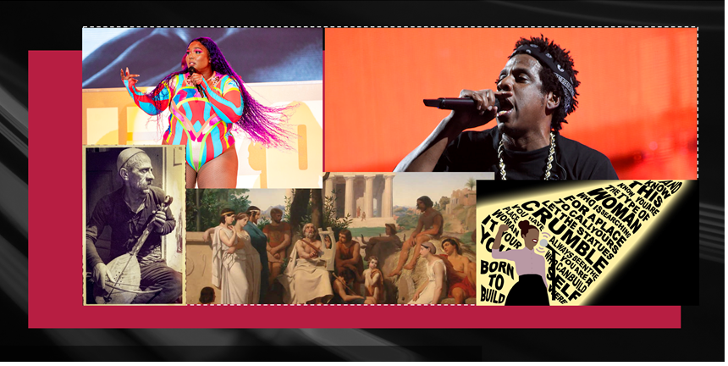
Learning Objectives & Methods
This course introduces students to the demands and conventions of academic reading and writing. It focuses on analyzing texts, building effective thesis-driven arguments, and using and citing evidence and secondary source material. Instruction on the stages of the writing process, from pre-writing exercises through rough drafts and revisions, forms a key part of the curriculum. The goals of this course are to help you acquire, practice, and improve upon the key skills used in academic writing. The goals of this course are to help you acquire, practice, and improve upon the key skills used in academic writing; and we will accomplish these goals by working through three common types of academic essays: a close-reading and comparative essay, a test-a-theory/lens essay, and a research essay.
Writing Process
In each unit, we will explore these questions and issues through response exercises, essay drafts, in-class workshops, and a finished essay built upon all of the previous activities. Through these assignments, you will become familiar with the messy yet rewarding process of reading, questioning, writing, rethinking, and rewriting.
Course Description
From ancient Greece to modern rap battles, we have gathered to hear and create stories that reflect the way we define ourselves and our communities. What accounts for the persistence – and complexity – of the oral tradition? How are the performances of artists such as Homer and Jay-Z uniquely characterized through the verbal art form? What is verbal art and oral performance and why is it important to study them? In this course we will attempt to answer these questions by studying oral storytelling in ancient and modern contexts. We will look at historical modes of storytelling - such as the ancient epic - to more contemporary mediums such as Tik Tok, Spoken Word, and Freestyle Rap. Throughout the course, we will consider together what orality and verbal art communicate that writing cannot, what we mean by “literacy,” and if we can ever even clearly distinguish the “oral” from the “written.”
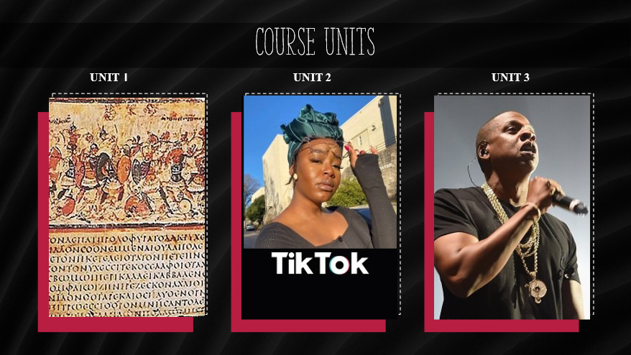
UNIT 1  For our first Unit, we will look at historically oral traditions and delve into the paradox of studying verbal art that has been passed down to us through written texts and material effects. We will study one of the oldest and most famous of oral epics - Homer’s Iliad - along with ancient Greek artifacts at the Harvard Art Museum and Boston Museum of Fine Arts.  For the first essay, we will close read and compare two sources to understand how studying sources in relation to each other can often deepen our understanding of either source. | UNIT 2  For our second unit, we shall ask what correctly categorizes something as verbal art. We will apply theories of oral epic to more recent verbal traditions by listening to the freestyle rap of Eminem, and watching performances of TikTok artist, Ayanna Albertson.  In the second essay, you will learn the distinction between a lens and a test-a-theory essay, and model one of these approaches in your analysis of a primary source. | UNIT 3  In our third unit, we will take a step back to consider how oral tradition functions in opposition or subversion to dominant culture by researching different contemporary sources. We will consider the modern podcast as exemplified by ‘The Joe Rogan Experience,’ multimedia exhibits in museums such as Harvard’s Peabody, and BIPOC rap artists such as Tupac and Nicki Minaj, among other subjects.  In the final essay, you will continue to practice the elements of academic argumentation while analyzing multiple sources - your chosen verbal art piece or oral performance and relevant research materials. You will create a compelling thesis that engages academic arguments being made about these performances and/or traditions.

